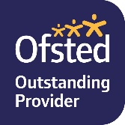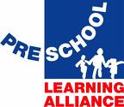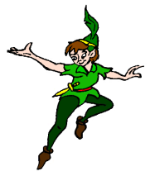

***Peter Pan***

***Playgroup***

Registered Charity 1031364

Ofsted Registration 113640

**Peter Pan Playgroup Uniform**

Our uniform is available to purchase in two sizes: 3-4 years and 5-6 years.

There is a choice of two colours of polo shirt, pink or blue, a round necked sweatshirt in navy. All items are embroidered with the Peter Pan logo. Pictures are available on the Peter Pan website.

Prices:

Round necked sweatshirts £8.75

Polo shirts £8.50

Special offer 1 x round neck sweat and 2 x polo £24.00

**Order form**

|  |  |  |  |  |  |  |
| --- | --- | --- | --- | --- | --- | --- |
|  | SIZE (PLEASE TICK) | | | | NUMBER | TOTAL COST |
| Pink polo shirt | 3-4years |  | 5-6 years |  |  |  |
| Blue polo shirt | 3-4years |  | 5-6 years |  |  |  |
| Round necked sweatshirt | 3-4years |  | 5-6 years |  |  |  |

|  |  |
| --- | --- |
| Child’s Name |  |
| Total amount enclosed |  |
| Signed |  |
| Date |  |